**Practical 13: One-way ANOVA (Extra Practice)**

**Part A: Using SPSS**

A professor is interested to know how different teaching methods affected students’ knowledge. Three different methods (punishment, indifferent, and reward) have been applied on three different groups of students and their exam scores are recorded as follow:

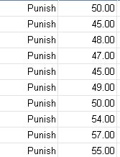 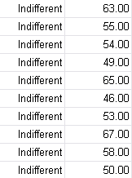 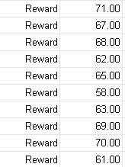

Carry out a One-way Independent ANOVA to test the hypotheses that:

1. reward results in better exam scores than either punishment or indifference
2. indifference will lead to significantly better exam scores than punishment

Assumptions for one-way ANOVA:

* Normal distribution of data
* Homogeneity of variances within groups should be assumed

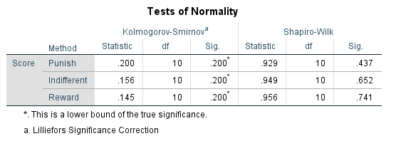**NORMALITY TEST**

**Punish method:**

$$H_{0}:Normality ofdata from Punish method can be assumed$$

$$H_{1}:Normality of data from Punish method can not be assumed$$

sig. = 0.437 (p > 0.05)

Test is not significant

Accept $H_{0}$

Conclusion: normality of data from Punish method data can be assumed

**Indifferent method:**

$$H_{0}:Normality of data from Indifferent method can be assumed$$

$$H_{1}:Normality ofdata from Indifferent method can not be assumed$$

sig. = 0.652 (p > 0.05)

Test is not significant

Accept $H_{0}$

Conclusion: normality of data from Indifferent method can be assumed

**Reward method:**

$$H_{0}:Normality of data from Reward method can be assumed$$

$$H_{1}:Normality ofdata from Reward method can not be assumed$$

sig. = 0.741 (p > 0.05)

Test is not significant

Accept $H_{0}$

Conclusion: normality of data from Indifferent method data can be assumed

**TEST FOR HOMOGENEITY OF VARIANCES**

$$H_{0}: homogeneity of variances can be assumed$$

$$H_{1}: homogeneity of variances cannot be assumed$$

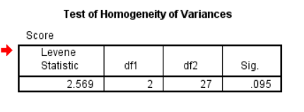

sig. = 0.095 (p > 0.05)

Test is not significant

Accept $H_{0}$

Conclusion: homogeneity of variances can be assumed

All assumptions for One-way ANOVA are met; therefore we can proceed with the test.

**ONE-WAY ANOVA**

$$H_{0}: all means are the same$$

$$H_{1}: at least two means are different$$

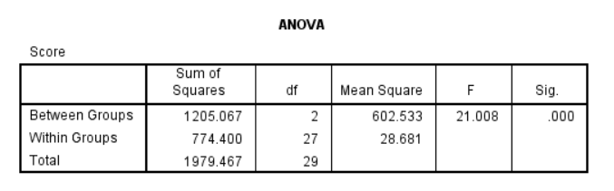

sig. = 0.000003 (p < 0.05)

Test is significant

Reject $H_{0}$

Conclusion: at least two means are different

One-way ANOVA test results state that at least two means are different, however it is unknown which means are actually different. Therefore, Post Hock test is performed on data.

**POST HOCK TEST**

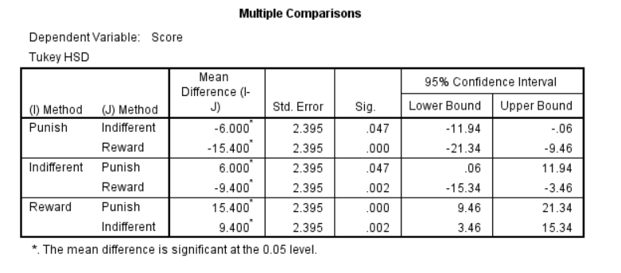

Results for hypotheses:

1. reward results in better exam scores than either punishment or indifference

True, because mean difference (reward - punish) = 15.4, and mean difference (reward - indifferent) = 9.4. There are positive values, it means that reward method results higher exam scores.

1. indifference will lead to significantly better exam scores than punishment

True, because mean difference (indifference - punish) = 6. There is positive value; it means that indifference method is better than punishment.

**Part B: Using R Studio**

A medical doctor would like to know the effect of different drugs to a disease. The pain score for each drug is recorded as follows:



Carry out a One-way Independent ANOVA to test the effect of different drugs.

Assumptions for one-way ANOVA:

* Normal distribution of data
* Homogeneity of variances within groups should be assumed

**NORMALITY TEST**

**Diclofenac:**

$$H_{0}:Normality of Diclofenac data can be assumed$$

$$H_{1}:Normality of Diclofenac data can not be assumed$$

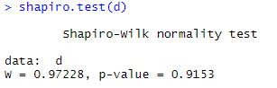

sig. = 0.9153 (p > 0.05)

Test is not significant

Accept $H_{0}$

Conclusion: Normality of Diclofenac data can be assumed

**Ibuprophen:**

$$H_{0}:Normality of Ibuprophen data can be assumed$$

$$H_{1}:NNormality of Ibuprophen data can not be assumed$$

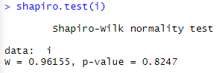

sig. = 0.8247 (p > 0.05)

Test is not significant

Accept $H_{0}$

Conclusion: Normality of Ibuprophen data can be assumed

**Paracetamol:**

$$H_{0}:Normality of Paracetamol data can be assumed$$

$$H_{1}:Normality of Paracetamol data can not be assumed$$

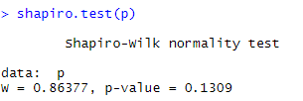

sig. = 0.1309 (p > 0.05)

Test is not significant

Accept $H_{0}$

Conclusion: Normality of Paracetamol data can be assumed

**Aspirin:**

$$H_{0}:Normality of Aspirin data can be assumed$$

$$H_{1}:Normality of Aspirin data can not be assumed$$

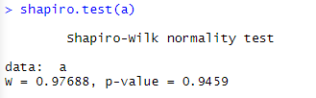

sig. = 0.9459 (p > 0.05)

Test is not significant

Accept $H_{0}$

Conclusion: Normality of Aspirin data can be assumed

**TEST FOR HOMOGENEITY OF VARIANCES**

$$H_{0}: homogeneity of variances can be assumed$$

$$H_{1}: homogeneity of variances cannot be assumed$$

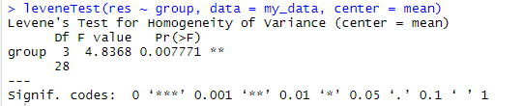

sig. = 0.007771 (p < 0.05)

Test is significant

Reject $H_{0}$

Conclusion: homogeneity of variances cannot be assumed

All data is normal, but homogeneity of variances within groups is not assumed. Therefore, we cannot continue with One-way ANOVA.